You could insert your child’s photo here by going to the toolbar, then Insert, Picture, and selecting an image from your files.
Or if you’re filling this in by hand you can just glue a photo here.
If you don’t want to include a photo just delete this box.
Who this passport can be shared with
[List all the people you’re happy for this passport to be shared with.
Do you want anyone in your child’s nursery/pre-school etc who comes into contact with your child to have access to it?
Do you only want to share it with staff in regular contact with your child, for example their key worker?]

[insert your child’s name]: personal passport

Date of birth: [insert date]

Passport created on: [insert date]

Passport expiry date: [insert date]

Passport created by: [insert your name]

Class: [insert your child’s class]

Key worker: [insert the name of your child’s key worker]

Deafness
Level of deafness
[Is your child deaf in their left ear, right ear or both ears?
Is your child’s deafness mild, moderate, severe or profound? Give details of each ear if different.]

What this means in practice
[Explain what your child can hear (and/or not hear) on a normal day. For example:
- Can your child usually hear speech in a quiet room?
- Would they still be able to hear if the speaker wasn’t facing them and/or there was lots of background noise?
- Can your child hear things like music or whistles used in games?]

Communication
Communication preferences
[Explain how your child prefers to communicate (e.g. speech, lip-reading, sign language, Makaton or a mixture of methods).]

Non-verbal gestures/signs to look out for
[If your child uses non-verbal gestures/signs/behaviour to communicate explain the main ones here and what they mean. For example, does your child take their hearing aids out if they’re feeling overwhelmed by background noise or are getting tired and need a break? Do they use any British Sign Language (BSL) or Makaton signs?]

Technology
Hearing technology
[Explain what hearing technology your child uses, if any (e.g. hearing aids, cochlear implants).]

Other technology
[Explain any other technology your child uses (e.g. radio aids).]

Tips on dealing with technology
[Give tips on what staff need to do to help your child use their technology safely and effectively. For example:
- where spare batteries are kept, and who knows how to change them
- how important it is not to let hearing technology get wet
- where their radio aid is kept and how to use it
- how to check the equipment is working and if a battery needs replacing.]

What helps
[Give details of anything people can do that will make a positive difference to your child and help them to access all aspects of life at nursery/pre-school etc. Try to be as specific and detailed as possible. For example:
- Does your child need to sit near the front of a group?
- Do they need regular breaks?
- Do they need support to join in games?
- Do they need visual support to follow instructions?]

What’s challenging
[List any activities or situations your child finds particularly challenging and explain what might help. For example:
- Does your child find it harder to hear/understand if someone isn’t looking at them, or if someone is shouting or speaking too slowly?
- Does your child get upset if someone shows frustration if they have to repeat themselves?
- Does your child find it difficult to join in whole-class activities because of too much background noise or too many people speaking at once?
- Does your child find some physical activities, such as climbing, difficult because they lose their balance easily?]

Staying safe
[What do people need to know to keep your child safe? For example:
- Does your child ever run away or wander off if not supervised? Will they hear a fire alarm or a shouted warning of danger?]
- Do they lose their balance easily and so fall over/get knocked over a lot?
- Do they need to be extra careful not to hit their head because of their implant/s?
- Do they have any allergies or other health conditions? If yes, then this should be covered by a separate care plan, but you could mention it here as well.]

What’s important
[Give details of what people, things and activities are most important to your child. For example:
- Does your child have any particular routines? Can they cope with changes to routine?
- Do they have a favourite object that they find comforting?
- Are there any people/places/things they’re very interested in?
- Do they have any fears, phobias or strong dislikes (e.g. afraid of animals, hates certain noises)?]

Additional information
[Use this space to give information about your child that hasn’t fitted in any of the other sections. For example, what’s it like for your child on the days when their hearing technology fails? What’s the best way to calm your child down if they get upset?
Perhaps your child might like to add something in here about themselves and/or how they feel about their deafness.]

Useful resources
[You might want to list some National Deaf Children’s Society resources here, for example:

Information for education professionals: www.ndcs.org.uk/professional_support/our_resources/education_resources.html

Supporting the Achievement of Deaf Children in Early Years Settings: www.ndcs.org.uk/supportingachievement

Deaf awareness information:
www.ndcs.org.uk/family_support/communication/deaf_awareness/index.html.

Or you might want to list reports on your child from professionals such as an educational psychologist or audiologist which you can provide copies of on request.]

Any questions?
[Give details of who to contact if someone has questions about your child, for example you could give your contact details and/or those of your child’s Teacher of the Deaf or other professional/s supporting them.]

If you have questions about childhood deafness or supporting a deaf child you can contact our Freephone Helpline on 0808 800 8880, at helpline@ndcs.org.uk or via Live Chat at www.ndcs.org.uk/livechat.

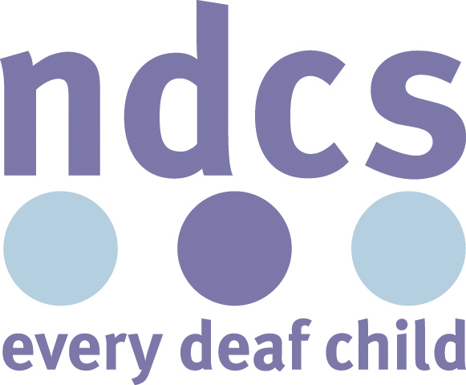
Personal Passport: Early Years
National Deaf Children’s Society resource: April 2016

